AM000 Asia China-Han-16 Character-See the light of the long days without forgetting

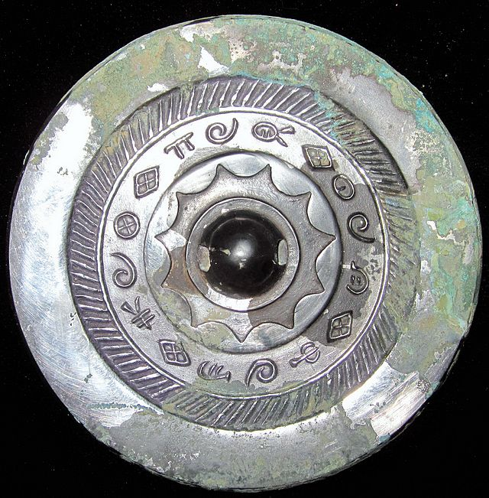

见日之光长毋相忘

See the light of the long days without forgetting

Ebay 1400 USD